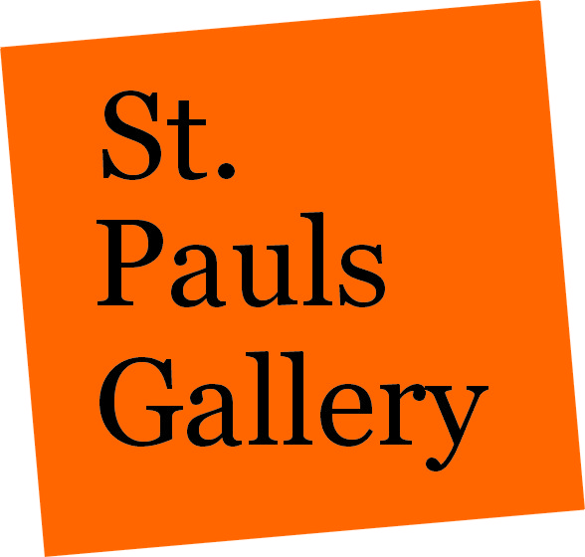
FOR IMMEDIATE RELEASE

29th August 2006

Storm Warning in Birmingham

The UK’s premier regional gallery, St Paul’s Gallery is proud to present the “Storm Warning” exhibition, as part of the travelling exhibition “Taken by Storm: Art of Storm Thorgerson”. The exhibition will be the biggest international show yet. With over sixty prints on display, the show will be the largest to date on the tour and will include artwork never seen anywhere else before.

Storm Thorgerson, first with Hipgnosis and then later in his own right, is the artist behind the images synonymous with identifying the pop culture of the 70’s throughout and into the Millennium (eg Pink Floyd’s “Dark Side of the Moon”, Led Zeppelin’s “House of the Holy”, Black Sabbath’s “Technical Ecstasy”). Creating visually beautiful and thought-provoking art, Storm’s work has featured on a variety of single and album covers and collected in books including “Eye of the Storm”, “Mind over Matter” and “Walk Away Renee”. Storm’s distinctive style has made his artwork one of the most recognisable in the music industry. He is responsible for the iconic images we associate with bands like Pink Floyd, Led Zeppelin, Peter Gabriel, and more recently The Cranberries, Mars Volta and Muse, including the cover for the number one album “Black Holes and Revelations”.

“I am trying to represent the music visually on a flat surface, and that is something the music cannot do by itself.”
– Storm Thorgerson. Chicago Time Out, 2005

The distinctive and edgy style of Storm Thorgerson’s work has an element of “performance” to it. Storm enjoys engaging the audience to provoke a reaction through the ‘temporary installations’ captured by the camera; is it reality or is it fantasy?

I like photography because it is a reality medium, unlike drawing which is unreal. I like to mess with reality. Bend reality. Some of my works beg the question of is it real or not? I use real elements in unreal ways. Is the man really on fire? Why would he just be standing there? Who put the beds on the beach? Why? Why is there a cow on the cover? It doesn’t have anything to do with the album, or does it? A boxer dog in designer boxer shorts on a beach?

Incongruity. I like to create things that are unlikely (dog in designer shorts), unbelievable (beds on a beach) and unacceptable (setting a man on fire). Make people doubt what they see. How real is real? My work triggers sufficient interest in what it ‘is’ and makes people ask what it ‘means’. – Storm Thorgerson

The “Taken By Storm: The Art of Storm Thorgerson” travelling exhibition launched in 2004 and has continued into 2006 including visits to Chicago, Los Angeles, Cleveland and San Francisco.

“Storm Warning” will open on 5th October at St Paul’s Gallery, 94 - 106 Northwood Street, Off St Paul’s Square, Birmingham B3 1TH England. The exhibition will continue until 28th October 2006. The official opening night will be held on 5th October from 6pm – 9pm. For further information on the gallery, please refer to www.stpaulsgallery.com.

Limited edition signed and numbered fine art prints; original sculpture and one-of-a-kind artwork will be available at the gallery and on the gallery website.

For a press pack, further information on the Birmingham exhibition, or to request an interview with Storm Thorgerson, please contact:

Nina Naran Robin Headlee
nina@mediabitch.com robin@mediabitch.com
+44 (0)7956 841 359 +44 (0)7799 034 710

Notes to Editor

St Paul’s Gallery was founded five years ago by Symon Bland and Neil Robinson. It is the “UK’s premier regional gallery”; the largest outside of London. The gallery has hosted various contemporary exhibitions by artists including Jason Brooks, Rob Youngson, John Salt, Jamie George, Julian Opie and Patrick Caulfield
.
In addition, the gallery has in-house collections which include art by Picasso, Dali, Rembrant, Warhol, Riley Hockey amongst many others.

St Paul’s Gallery also has the largest ever permanent collection of album cover fine art prints in the world, which is constantly growing! The gallery has also hosted many music inspired projects, launches and on occasion if you’re lucky, impromptu gigs. The Move reunion, Bev Bevan, Gordon Giltrap and Ocean Colour Scene are just a few of the performers that have!

