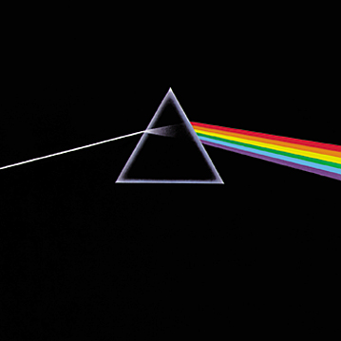
MEDIA ALERT AND PHOTO OPPORTUNITY

PINK FLOYD: ANOTHER PIECE ON THE WALL

Featuring Original and Performance Art from Pink Floyd

ROCKVILLE CENTRE, N.Y.—September 9th, 2006— This will be a September to Remember as Pink Floyd makes its mark on New York once again; only this time in the form of Roger Waters, Storm Thorgerson, and Trevor Carlton!

On Saturday September 16th artist Trevor Carlton will be creating his latest painting Dark Side of My Mind, a visual performance piece set to Pink Floyd’s Dark Side of the Moon. This performance will mark the opening of The Art of Pink Floyd exhibition featuring the art of Storm Thorgerson, and Roger Water’s masterpiece The Wall. The exhibition is to coincide with Waters performances in New York; at Madison Square Garden September 12th & 13th and at the Nikon at Jones Beach Theater Friday the 15th.

Storm Thorgerson is the creative brain behind the iconic images that have become immortalised and synonymous with the bands themselves; these include album covers for bands such as Pink Floyd, Black Sabbath, Led Zeppelin, The Offspring, The Cranberries, Mars Volta and Muse amongst many others.

In particular, Storm shares a special relationship with the Floyds from before they were famous and has had the pleasure of creating the artwork for twelve of Pink Floyd’s fourteen album covers, including Dark Side of the Moon. Please visit www.takenbystorm.us for more information and limited edition fine art prints of his work.

WHAT | Photography by original Pink Floyd album artist Storm Thorgerson  Original artwork used to produce the 1982 movie The Wall  Visual performance set to Dark Side of the Moon by artist Trevor Carlton
WHEN | Saturday, September 16th  6 - 10 p.m. – Artist Performance and Signing  Sunday, September 17th  12 - 4 p.m. – Artist Appearance and Signing  Exhibition – September 13th – October 13th  Hours: Tuesday-Sunday 11 a.m. – 6 pm  Nights: Friday & Saturday till 10pm
WHERE | Gifted Images Fine Art Gallery  7A North Park Avenue  Rockville Centre, NY 11570  516-536-6886  www.takenbystorm.us
PHOTO  OPPORTUNITY  ADDITIONAL INTERVIEWS | The iconic imagery of Pink Floyd is captured on sprawling canvases, paper and wood. From original album cover photographs by Storm Thorgerson to the larger than life performance art of Trevor Carlton.  Interviews with the artists are available before/during/after the event. Please contact Jay Taylor at 954-817-0273 to schedule.
IN HIS  OWN WORDS | I like photography because it is a reality medium, unlike drawing which is unreal. I like to mess with reality. Bend reality. Some of my works beg the question of is it real or not? I use real elements in unreal ways. Is the man really on fire? Why would he just be standing there? Who put the beds on the beach? Why? Do Pigs Fly? What does a cow have to do with the music? Or does it?  – Strom Thorgerson

