Artwork by Storm Thorgerson

Dark Side of the Moon – 30th Anniversary – Pink Floyd – 2003

We simply couldn’t bring ourselves to hold an exhibition of Storm’s work without including a version of the famous prism from Dark Side of the Moon. Arguably, The Dark Side of the Moon cover is Storm Thorgerson’s most recognisable album artwork. The 30th Anniversary edition (shown here) captures the constellation of the 3 elements that the original cover in 1973 contained -- madness, lost opportunity and megalomania. As an album, Dark Side of the Moon spent the longest time in the charts by far, fourteen years in Billboard’s Top 200, and selling over thirty million copies.

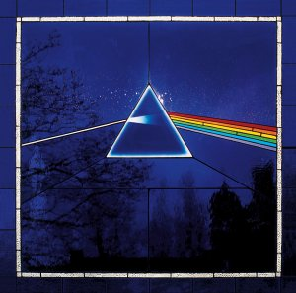
Compliments of CCA Galleries

“When the super audio CD (SACD) of Dark Side of the Moon was made, we felt it was appropriate to redo the original cover in a sympathetic fashion in as much as the sound was remixed in 5.1 surround sound in exquisite quality and definition. As pure a rendition as you could get so we wished to re-express the design its purist fashion. What better than the medium of glass to express an idea about glass and light via a prism. So we made a stain glass window specifically constructed to the proportions of the original design in 1973 and photographed it, backlit by the autumn sun. The imperfections inherent in stain glass were brought out as well as the suspended colours that stain glass provides. A thing of beauty … or so I thought.” – Storm Thorgerson, private interview, 2004.

A press kit is available containing a CD Rom with several images of Storm’s work, a description of each, a biography and a photograph of Storm. Please contact:

Nina Naran Robin Headlee
nina@mediabitch.com robin@mediabitch.com
+44 (0)7956 841 359 +44 (0)7799 034 710

